**I. Modeling**

This document summarizes the modeling of following elements

1. Distribution Line
2. Load
3. Step Voltage Regulator
4. Switches

**1. Distribution Line Modeling**

The Distribution lines are modeled using

1. SimPower System Three Phase and Single-Phase Pi Section Line model
2. Custom Built Three Phase, Two Phase and Single-Phase Pi Section Line
3. **Simpower System Three Phase and Single-Phase Pi Section Line model**

This is an inbuilt model available in Simulink Library as shown in Fig 1. The line parameters R, L, and C are specified as positive and zero-sequence parameters that take into account the inductive and capacitive couplings between the three phase conductors, as well as the ground parameters. This method of specifying line parameters assumes that the three phases are balanced. This is a source of error since the lines are not balanced in the case of a distribution system.

Another model which is more accurate and that captures the unbalances in distribution line is the “Distributed Parameter Line” model. But the requirement of propagation time to be smaller than the specified Sample time value will make it difficult for dynamic simulation. In order to simulate this model, Sample time must be very much less than 0.005µs which is not feasible.

Fig 1: SimPower System Pi Section Model

The distribution line parameters in phase domain (as 3x3 matrices) provided in IEEE 13 bust benchmark document [1] is used to obtain the sequence parameters. The RXB matrices provided in Ω/mile are converted to Ω/km and length of line is converted from ft to km. Then the phase RLC 3x3 matrix values in Ohm, Henry and Farad respectively are calculated. The phase to sequence conversion is applied to obtain positive and zero sequence value of RLC. An example for line section 1 is shown below.

**Configuration 1:**

Z (R +jX) in ohms per mile

0.4576 1.0780 0.1560 0.5017 0.1535 0.3849

0.4666 1.0482 0.1580 0.4236

0.4615 1.0651

B in micro Siemens per mile

5.6765 -1.8319 -0.6982

5.9809 -1.1645

5.3971

a=1; % Loading Factor

Ts=50e-6;

% phase to sequence conversion of RXB matrices

c=1*exp(sqrt(-1)*(120*pi/180));

T=[1 1 1;1 c*c c;1 c c*c];

Tinv=1/3*[1 1 1;1 c c*c;1 c*c c];

% Simulation data for the IEEE 123 Node Test Feeder model

mi2km = 1.60934;% miles to km conversion

ft2km = 0.0003048; % feet to km conversion

ms2F = 1*1e-6/(2*pi*60);% microsiemens to Farads conversion

%% Configuration 1

% Series Resitance and Reactance - ohm/mile

R_1 = [0.4576 0.1560 0.1535;0.1560 0.4666 0.1580;0.1535 0.1580 0.4615];

X_1 = [1.0780 0.5017 0.3849;0.5017 1.0482 0.4236;0.3849 0.4236 1.0651];

% charging susceptance - microsiemens/mile

B_1 = [5.6765 -1.8319 -0.6982;-1.8319 5.9809 -1.1645;-0.6982 -1.1645 5.3971];

R_1 = R_1/mi2km;

Rseq=Tinv*R_1*T;

R1_1=Rseq(2,2);R0_1=Rseq(1,1);

L_1 = (X_1/(2*pi*60))/mi2km;

Lseq=Tinv*L_1*T;

L1_1=Lseq(2,2);L0_1=Lseq(1,1);

C_1 =(B_1*ms2F)/mi2km;

Cseq=Tinv*C_1*T;

C1_1=Cseq(2,2);C0_1=Cseq(1,1);

This code is provided in “InitFcn” section which can be located by right click🡪 Model Properties 🡪Callbacks in Simulink.

The sequence values of RLC and length are used as input in the Three Phase or Single-Phase Pi Section Line block as shown in Fig 2.

Fig 2: SimPower System Three Phase Pi Section Input

1. **Custom Built Three Phase, Two Phase and Single-Phase Pi Section Line**

A custom-built Pi section line is also used for modeling lines as shown in Fig 3. They are especially used to model the lines near the Step Voltage Regulators (SVR). This was done since lines near SVR modeled using Simpower system Pi line blocks lead to unstable simulations. They are also used when 2 phase lines are present.

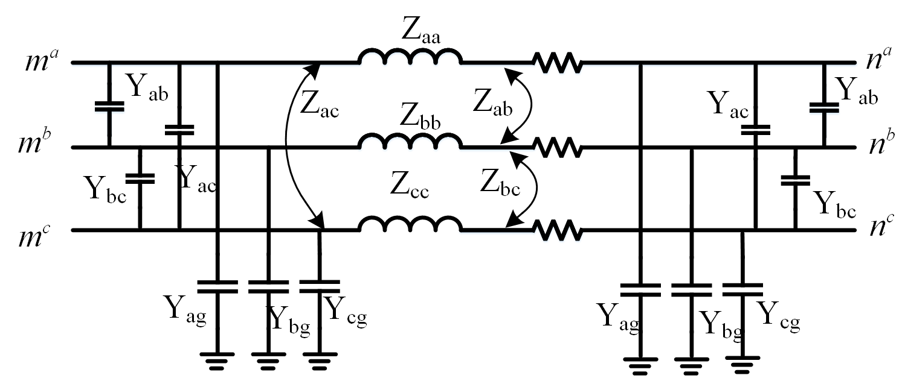

Fig 3: Custom Built Three Phase Pi Section Line

The phase RLC 3x3 matrix values in Ohms, Henry and Farad respectively is calculated and used as input to the custom-built Pi section model as shown in Fig 4.

Fig 4: Custom Built Three Phase Pi Section Input

**2. Load Modeling**

The loads are modeled using the Simpower System Three Phase and Single-Phase series RLC Loads. The main drawback of this load modeling is that different types of load models or ZIP models (Constant Impedance, Constant Current and Constant Power) are only activated while performing a load flow analysis using the Simulink Loadflow tool. While doing a dynamic simulation all these models will be considered as a constant impedance load which leads to differences in steady state voltages compared to the voltages in benchmark document.

Fig 5: Load Modeling

Another key feature included in load modeling is the **loading factor (a)** as shown in Fig 5. This allows the user to run simulations with different loading. Note that this is a static functionality and cannot be changed during simulation to have a dynamic change in the loading. For such cases a dynamic load should be used. This loading factor can be varied by modifying value of **a** in the code provided in “InitFcn” section which can be located by right click🡪 Model Properties 🡪Callbacks in Simulink.

The Capacitor bank used for reactive power support is also modeled as a series load.

**3. Step Voltage Regulator**

Voltage regulators in the IEEE test distribution feeders are assumed to be “step-type” and are connected in the substation and also in specified line segments inside the feeder far from substation. The regulators can be three-phase or single phase. The changing of taps on a regulator is controlled by the Line Drop Compensator (LDC) when the voltage to be regulated is of a remote node far from the regulator. A simplified circuit of an analog compensator [2] and how it is connected to the feeder through a potential and current transformer is shown in Fig 6. In the transformer, there are four settings that are required for the compensator circuit.

They are

1. The compensator R and X setting
2. The reference voltage level setting
3. The bandwidth setting
4. The time delay setting.

The voltage setting gives the desired voltage to hold at the regulation point and bandwidth defines the allowed variance of the regulation point voltage centered at the desired Voltage Level. The time delay is the delay before a tap change is made when the voltage is not within the bandwidth.

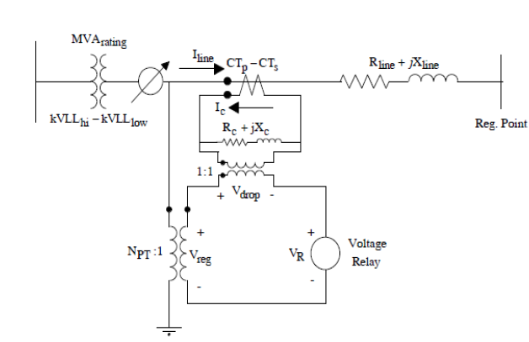

Fig 6: Analog Compensator

The goal of the compensator circuit is such that the voltage across the compensator voltage relay will be a scale model of the actual voltage at the regulation point. The per-unit voltage of the compensator voltage relay should be equal to the per-unit voltage at the regulation point. In order to make this happen the per-unit R and X settings must be equal to the per-unit equivalent line impedance from the regulator output to the regulation point.

A single phase SVR is modeled and combination of these are used to create three phase SVRs as shown in Fig 7. SVR consists of a variable ratio transformer, LDC and voltage regulator control. The variable-ratio transformer has taps on the primary of the transformer. The turns ratio is calculated by the LDC and voltage regulator control. The turns ratio is calculated as

**N= $\frac{1}{ (1+TapPosition*DeltaU)}$**

Therefore, to raise the secondary voltage, a tap down operation is required and vice versa to lower the voltage. A maximum/minimum tap is also included so that the regulator would not tap beyond a certain point. The input parameters required for SVR are shown in Fig 8.

In case of IEEE 123 bus system, the SVR at substation is a ganged type. The taps of all phases are operated together based on voltages of phase A as shown in Fig. 9.

Fig 7: Step Voltage Regulator Model

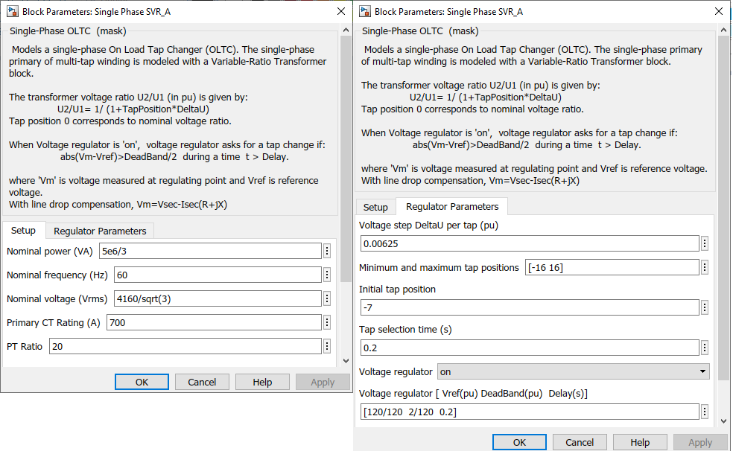

Fig 8: Step Voltage Regulator Model Inputs

Fig 9: Ganged Step Voltage Regulator Model

A test is conducted where an additional load is added to node 98 of at 3s and removed at 7s. The reference voltage is chosen as 124V, bandwidth as 2V and delay as 0.4s. It can be seen that as soon as load is added at 3s, the voltage drops and goes out of bandwidth for all 3 phases. This led to taps operation of the regulator after a delay of 0.4 sec as shown in Fig 10. This is continued until voltages of all phases are within the bandwidth. The reverse operation happens at 7 sec as soon as load is removed. It can be seen that lowering the tap led to a rise in voltage since taps are on primary of transformer. This is different as compared to benchmark document since taps are on secondary of the transformer. But it only leads to an opposite sign and reverse direction of tap operation when comparing with benchmark.

Fig 10: Tap Operation

**4. Switches**

The switches are modeled using the Three Phase Breaker model as shown in Fig 11. The status of breakers is taken similar to the benchmark document. A combination of these breakers can be controlled by external signal and can be used to connect/disconnect parts of feeder and hence making multiple islands which can be used to conduct grid forming inverter studies.

Fig 11: Measurement Subsystems

**II. Measurement Subsystems**

In order to capture all dynamics of the model, Three-Phase VI Measurement blocks are connected to every node. The voltage, current and calculated power measurements can be used as inputs to optimization routines, adaptive or optimal controllers as discussed in [3] and [4]. Three measurement subsystems are created namely Node Voltages subsystem, Regulator Taps subsystem and Substation Power subsystems as shown in Fig 12. The Node Voltage subsystem collects all node voltages in pu and store it in a variable V13 with 0.1sampling time. The Regulator Tap subsystem shows the voltage profile at regulating point with reference voltages and bandwidths. The Substation Power subsystem calculates the head end (substation) power.

Fig 12: Measurement Subsystems

**III. Assumptions and Approximations**

Two main assumptions and approximations are

* Distribution Lines modeled as Pi-Section which assumes a balanced line.
* Dynamic Simulation in Simulink will consider all Loads as Constant Impedance Loads.

These assumptions will result in small differences in voltage profile compared to the voltage profile given in the Benchmark Document.

**IV. References**

[1] <https://cmte.ieee.org/pes-testfeeders/resources/>

[2] W. Kersting, Distribution System Modeling and Analysis, ser. The Electric Power System Engineering Series. CRC Press, 2002.

[3] A. Suresh, R. Bisht and S. Kamalasadan, "A Coordinated Control Architecture With Inverter-Based Resources and Legacy Controllers of Power Distribution System for Voltage Profile Balance," in IEEE Transactions on Industry Applications, vol. 58, no. 5, pp. 6701-6712, Sept.-Oct. 2022, doi: 10.1109/TIA.2022.3183030.

[4] A. Suresh, R. Bisht and S. Kamalasadan, "ADMM Based LQR for Voltage Regulation Using Distributed Energy Resources,"2020 IEEE International Conference on Power Electronics, Drives and Energy Systems (PEDES), 2020, pp. 1-6, doi: 10.1109/PEDES49360.2020.9379625.